Note that this document provides the questions for the C-Change application. To be complete, you must submit the application online as well as the reference requirement. This document lets you see what is on the application while providing you time to think about and write out the answers to the open ended long questions. You must submit this online through the online application.

Contents
Reference requirements. 1
Application Questions: 2
Link to start application: 2
Application Questions: 3
Grant Request 4
Open Ended Questions 5
Questions? 6
Pausing & Resuming Application 7

Reference requirements.
Additionally, you will be required to have a reference complete a form with questions we provide. This section will be updated once we have the link to that form. For your information, here are the questions we ask. Again, this must be submitted online from the reference. One reference satisfies the requirement; however, you can request more.
- Your relationship with the applicant
- How long have you known the applicant?
- What is the greatest strength you see in this person? Explain how you have seen it used.
- Describe the leadership competencies this person exhibits. Explain how you have seen these used.
- What do you hope this candidate will learn or discover through Cincy Next/C-Change that will further contribute to their organization?
- Cincy Next/C-Change is a competitive program. The more we know, the better. Please provide any other thoughts you have as to why this person would be an asset and key contributor to this year's program.

Link to send reference to complete reference form:
C-Change: https://portal.cincinnatichamber.com/cpbase__form?id=a0UJx00000aX173
Cincy Next: https://portal.cincinnatichamber.com/cpbase__form?id=a0UJx00000a0Gsr

Warning: If you want to exit and come back to a started (but not completed) application, you MUST hit pause. Exiting does not save your application.

Application Questions:
Admission is competitive and space is limited. Please submit your application online as soon as possible for the best opportunity to be accepted. If you need to step away from your application and finish it at a later date, you will be able to do so.

To complete your application, you will need to
- Complete the online application by October 14, 2025. The online application includes open-ended questions. We recommend downloading this document with the questions, taking time to think about and answer them, and saving them on the document. Then copy and paste into the online application when ready.
- Have a reference complete the reference form online. See above.
- There will be a non-refundable $50 application fee due at the time of submission. Once you hit the submit button, you will be automatically redirected to make your payment. Your application will not be considered complete or reviewed until we receive this payment. If you have any issues submitting your application or processing your payment, please contact Andrea Mersmann at amersmann@cincinnatichamber.com for C-Change and Kendra Perkins at kperkins@cincinnatichamber.com for Cincy Next.

To begin, you must have a Chamber portal login. If you have attended a Chamber event last year, you should have one. If you need to create one, you can do so here: https://portal.cincinnatichamber.com/s/new-registration?startURL=%2Fs%2F

Link to start application:
C-Change: https://portal.cincinnatichamber.com/s/c-change-application
Cincy Next: https://portal.cincinnatichamber.com/s/cincy-next-application

Application Questions:

Your Basic Information
- Name
- Job Title
- Company/Organization
- Work Email Address
- Personal Email Address
- Preferred Email Address (throughout program)
- Years of overall Professional Experience as of March 2026
- Your LinkedIn URL
- Work Phone Number
- Personal Phone Number
- Home Address
- Company Address
- Country of Origin
- Date of Birth
- Race/Ethnicity
- Gender
- Sexual Orientation
- What are your pronouns?
- Are you a Veteran?
- Do you have any dietary restrictions? If so, what are they?
- Do you need any special accommodations to participate in this program (this is only asked to ensure we design the experience in a way that is accessible to all)?

Your Organization Information
- Industry/Org type
- Your supervisor’s name:
- Your supervisor’s email:
- Have you talked with your organization leadership about applying?
- Do you have full support from your employer for the tuition financial commitment required to take part in the program? Financial commitment from organization is not required. There is an option for self-pay or a combination of self- and organization pay.
- Do you have full support from your employer for the required time away from work to participate in the program?

Your Employment History
Begin with your current employer and go back successively through your previous employers. Include your title, organization name, and years of work. List your last 3 employers, if applicable. No need to go back to college or high school, unless work during college was full time.
- Current Employer
- Previous Employer #1
- Previous Employer #2
- Previous Employer #3

Grant Request
- Grants: Partial grants up to $1,300 for C-Change and $1,000 for Cincy Next may be available for small non-profits, entrepreneurs, or those self-paying based on need, etc. Would you like to apply for grant money?
- If yes to applying for grant, enter grant amount requested.
- If yes to applying to grant, please briefly explain why you are requesting financial assistance and how you think your participation in the program would provide a distinct and positive addition to the class. (open ended)
- If you do not receive the grant requested, will you still be able to take part in the program if accepted?

Supplemental Information
- Collectively, how many years have you lived in the Cincinnati region?
- Have you previously applied to or participated in a Cincinnati Regional Chamber or other community leadership program (e.g., Leadership Cincinnati, WE Lead, C-Change, Cincy Next, Urban Leaders Program, Leadership Northern Kentucky)?
- If yes, which program(s) and what year(s)?
- How did you hear about this program?
- Please share by whom you were referred or how you heard about the C-Change program (if applicable).
- Have you spoken with anyone at the Cincinnati Chamber about C-Change/Cincy Next? If so, whom?
- Do you know anyone else who is applying to this program? If yes, what is your relationship with that person? This can be from your personal or professional worlds.

Open Ended Questions
Please bring your true self to the application. So often individuals try to be so professional that we do not get to know them. We want to get to know you. Please avoid responding with just 2 or 3 sentences. Again, we want to get to know you.
- Why do you want to take part in in this program? What are 2-3 goals you would like to achieve through your participation, both during the program year as well as beyond?
- Share your Relevant Leadership Experience & Community Involvement from the past 5 years. Please list membership, leadership roles and/or awards, community, civic, professional, religious and social organizations that have been of significance to you. Include years/dates. Note that having relevant leadership experience and community involvement is not a requirement of the program. This is not limited to experiences that would go on a resume. Soccer coach, etc., count! Feel free to bullet point this. Max of 1000 words. Include years.
- Briefly describe a significant accomplishment (can be professional, personal, community, etc.) or something of which you are proud. BE SPECIFIC. Describe the situation, actions taken, and your leadership role. 300 words or less.
- Describe a mistake from the last five years that had a big impact on your personal or professional life, and how that experience changed the way you operate/what you learned. Be specific and do not generalize. Everyone experiences setbacks, challenges and/or failures. Please share yours. 500 words or less.
- Describe one of the most impactful experiences you have had in the Cincinnati region.
- How do you respond when being challenged regarding something that is prohibiting progress? Share a specific example.
- What will you bring to the class? Why should you be selected?
- Acceptance into this program is competitive. Please share with us something else, not mentioned in this application, that will help us get to know you better as an individual. This can be personal or professional, serious, or fun.

Additional
- Participants of the program may be asked to engage in pre-class assignments that will require approximately 1-2 hours during the weeks prior to each session. Will you be able to contribute the time needed to fulfill these assignments?
- Participants of the program will be required to take part in a small group project that will require approximately 4-6 hours/month outside of the sessions. Will you be able to contribute the time needed to fulfill this requirement?
- I understand the purpose of this program, the attendance requirements, and the time and energy necessary to make it a successful experience. I will commit fully to the program and will block my calendar for the program dates to make this a priority.

- Please submit your biographical sketch. Bios should be limited to 100 words and in third person. A sample sketch is noted below the box. This information, along with your headshot, will be published in a directory to all participants.
  - Open text box
  - Example to share:
    - e.g. "Mary Ann Moore, researcher and writer, president of the Smith Associates consulting firm. She received her B.A. in Political Science from the University of Chicago. In recognition of her work as Director of Public Information for the City of Cincinnati, she was chosen one of Cincinnati's Women of the Year in 2021. A former staff member of the United Way, she is a board member of the Mental Health Association, WCET, and Council on World Affairs. In addition to family activities with her husband, Geoff and their son, she enjoys photography, travel, and tennis."
- Upload your preferred headshot
- Sign
- Supply a reference. In your application, please supply the name, title, organization, and email address of the person that will complete a reference for you. This will need to be completed by October 14, 2025. See information on reference on first page.
  - Reference name
  - Reference title
  - Reference organization
  - Reference email address
- Pay Application Fee

Questions? For C-Change, email Andrea Mersmann at amersmann@cincinnatichamber.com. For Cincy Next, email Kendra Perkins at kperkins@cincinnatichamber.com.

Pausing & Resuming Application
- You may pause your application by clicking the “Pause” button in the bottom left of the questionnaire page.
  - You will be allowed to pause even if you receive notifications that the “required field must be complete.”
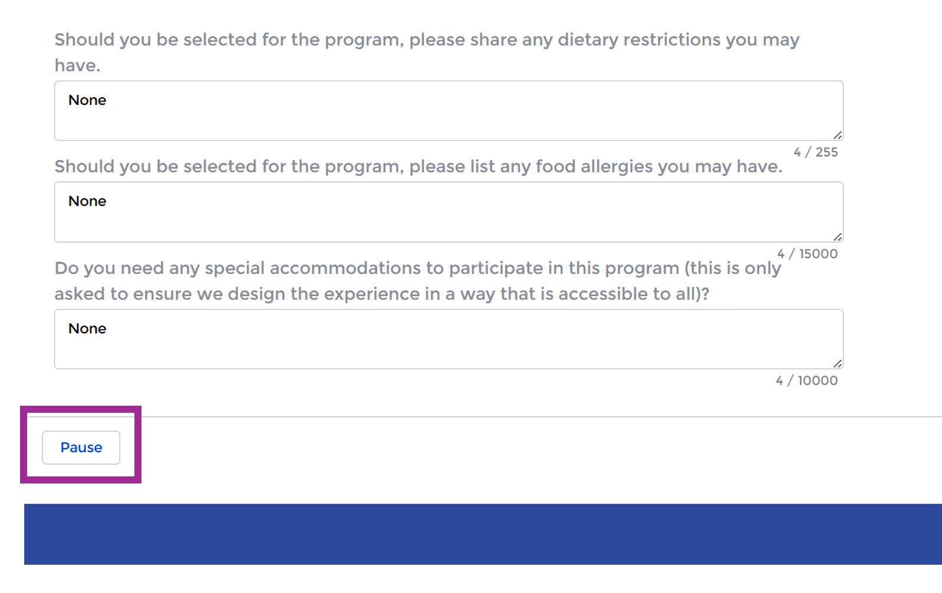

- To resume your application login to your portal profile page: https://portal.cincinnatichamber.com/s/#/profile/my_info/
  - Select “Application(s) in Progress” tab in the vertical navigation menu.
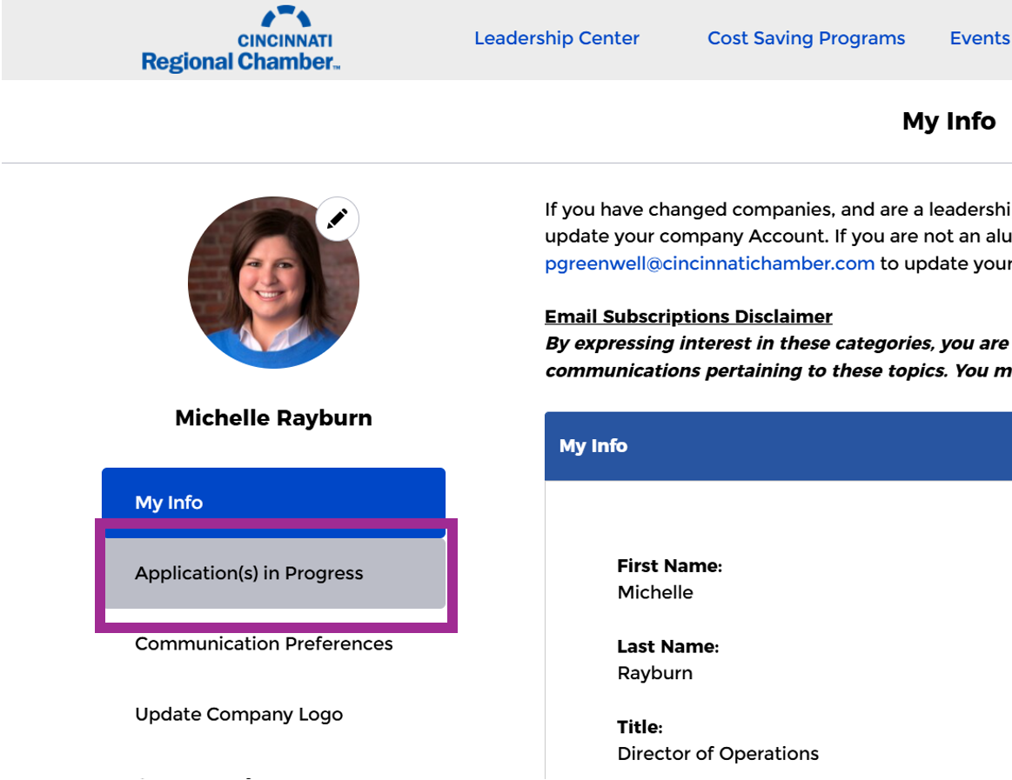

- Click the “Resume” button on the Paused Flows page to continue your application.
***IMPORTANT: You must complete the page you resumed and click to the next screen in order to pause your application again. If you pause your application on the same page you resume, it will be deleted by default.

